**CMPE 137**

**Lab 0 - Hello World**

*Last updated: 08/03/2015*

In this lab, you build a HelloWorld Android application with a background image. The app has

a single screen with the text message “Hello world from xxx!” in the center, where xxx is your

name. The background image can be any picture, including your portrait. :)

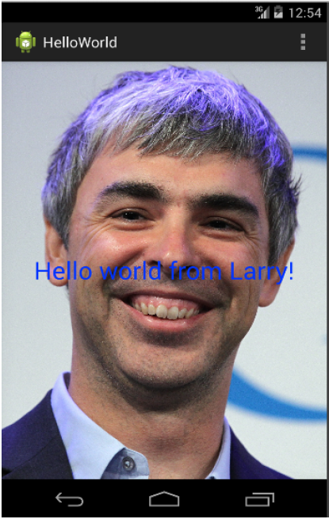

Please reference the following as you prepare for this assignment: <http://techcrunch.com/2015/11/23/android-studio-2-0-with-improved-android-emulator-and-instant-run/>

**Submission :** Please submit your job source code and resources files through Canvas. You

can include the whole project folder, excluding the bin or lib subfolders if you use Eclipse. In

short, do not include jars or compiled class files. At the top directory level, however, you want

to add three files: (1) README.txt with your name, student ID, and email ID, (2) a screenshot

of your app, named screenshot.jpg, and (3) your app binary (see <http://developer.android.com/tools/building/building-studio.html>) named HelloWorld.apk.

You can find the .apk file at the following location in your project:

app/build/outputs/apk/*yourappname*-debug.apk